**Homework 5 – Routing Protocols Network**

**CSCE 4535 Final Grade 8%**

**Build the network with the following specifications using packet tracer as shown in diagram below:**

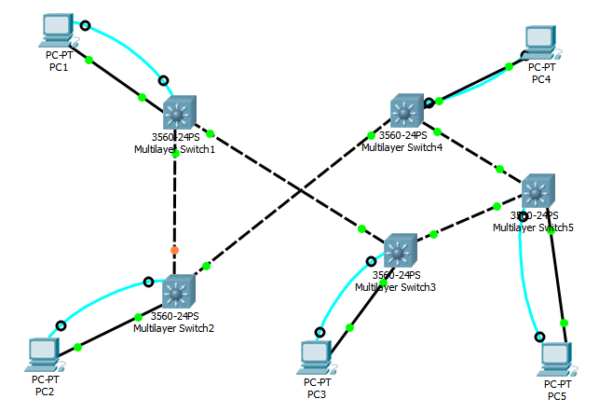

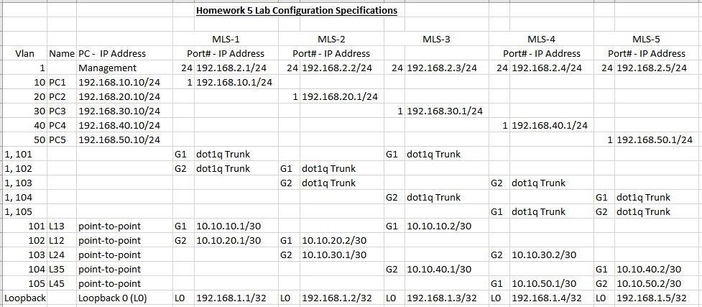

**The network consists of 5 PC’s and five Multilayer switches (MLS). PC1 – PC5 connect to MLS1 – MLS5 on fa0/1 port each.** **The IP addresses for vlan 1, Management and MLS, Loopback address are documented in the included spreadsheet. PC1 is on vlan 10, PC2 is on vlan 20, PC3 is on vlan 30, PC4 is on vlan 40 and PC5 is on vlan 50. MLS1 connects to MLS2 & MLS3, MLS2 connects to MLS1 & MLS4, MLS3 connects to MLS1 & MLS5, MLS4 connects to MLS2 & MLS5 and MLS5 connects to MLS3 & MLS4. The trunks for each link along with the IP addresses for each link is also documented in the included spreadsheet.**

* **Configure the following:**

1. Console cable for PC1-5 for management of MLS1-5
2. Ethernet cable for PC1-5 to MLS 1-5 port fa0/1 for user network
3. Set IP configuration for each PC as assigned
4. Create vlan 10, 20, 30, 40, 50 on MLS1-5 and name them PC1-5 respectively
5. Set “switchport mode access” for port 1 on each MLS
6. Set “switchport access vlan xx” for port 1 on each MLS
7. Set interface description for each interface and vlan
8. Set IP address for each vlan as assigned
9. Set up dot1Q trunk between MLS1-5 with vlans 101-105 using gigabit 1 & 2 ports as documented
10. Set IP address for each vlan as assigned on all MLS
11. Set loopback interface for each router
12. Apply Security Script to setup the following:
    1. Configure Hostname for MLS-1
    2. Configure enable “secret password” cisco
    3. Configure “line console 0 password” cisco
    4. Configure the console Idle privilege exec timeout of 5 minutes
    5. Now encrypt the console password
    6. Now add a banner “No unauthorized access allowed!”
    7. Configure vty lines 0-4 for remote access
    8. Configure password “cisco” for remote login
13. Save your configuration for MLS1-5
14. Save your Packet tracer activity file (.pkt) on your USB drive. You will need it for Lab in class
15. Please note that we have not configured any routing so not everything is supposed to work at this time. You should be able to figure out what is supposed to work, so don’t ask me. We will use this Homework as a base .pkt file for Lab7-8 where we will learn about various routing protocols.

* **Submit the following in a word file for grading:**

1. Submit the configuration items from MLS1-5 for this homework for grading

MSL1

hostname MLS1

!

!

enable secret 5 $1$mERr$hx5rVt7rPNoS4wqbXKX7m0

!

interface Loopback0

ip address 192.168.1.1 255.255.255.255

!

interface FastEthernet0/1

description Allows VLAN connection for PC1

switchport access vlan 10

switchport mode access

! interface GigabitEthernet0/1

switchport trunk allowed vlan 101

switchport trunk encapsulation dot1q

!

interface GigabitEthernet0/2

switchport trunk allowed vlan 102

switchport trunk encapsulation dot1q

!

interface Vlan1

description Management VLAN for PC1

ip address 192.168.2.1 255.255.255.0

!

interface Vlan10

description VLAN connection for PC1

mac-address 0060.7031.ec01

ip address 192.168.10.1 255.255.255.0

!

interface Vlan101

description Used for VLAN Connection from MSL1 to MSL3

mac-address 0060.7031.ec02

ip address 10.10.10.1 255.255.255.252

!

interface Vlan102

description Used for VLAN connection from MSL1 to MSL2

mac-address 0060.7031.ec03

ip address 10.10.20.1 255.255.255.252

!

banner motd ^CNo unauthorized access allowed!^C

!

!

!

!

!

line con 0

exec-timeout 5 0

password 7 0822455D0A16

login

!

line aux 0

!

line vty 0 4

password 7 0822455D0A16

login

transport input telnet

!

!

!

!

End

MSL2

service password-encryption

!

hostname MLS2

!

!

enable secret 5 $1$mERr$hx5rVt7rPNoS4wqbXKX7m0

!

interface Loopback0

ip address 192.168.1.2 255.255.255.255

!

interface FastEthernet0/1

description Allows VLAN connection for PC2

switchport access vlan 20

switchport mode access

!

interface GigabitEthernet0/1

switchport trunk allowed vlan 102

switchport trunk encapsulation dot1q

!

interface GigabitEthernet0/2

switchport trunk allowed vlan 103

switchport trunk encapsulation dot1q

!

interface Vlan1

description Management VLAN for PC2

ip address 192.168.2.2 255.255.255.0

!

interface Vlan20

description VLAN connection for PC2

mac-address 00d0.bcbd.6203

ip address 192.168.20.1 255.255.255.0

!

interface Vlan102

description Used for VLAN connection from MSL2 to MSL1

mac-address 00d0.bcbd.6201

ip address 10.10.20.2 255.255.255.252

!

interface Vlan103

description Used for VLAN connection from MSL2 to MSL4

mac-address 00d0.bcbd.6202

ip address 10.10.30.1 255.255.255.252

!

banner motd ^CNo unauthorized access allowed!^C

!

!

!

!

!

line con 0

exec-timeout 5 0

password 7 0822455D0A16

login

!

line aux 0

!

line vty 0 4

password 7 0822455D0A16

login

transport input telnet

!

!

!

!

End

MSL3

hostname MLS3

!

!

enable secret 5 $1$mERr$hx5rVt7rPNoS4wqbXKX7m0

!

interface Loopback0

ip address 192.168.1.3 255.255.255.255

!

interface FastEthernet0/1

description Allows VLAN connection for PC3

switchport access vlan 30

switchport mode access

!

interface GigabitEthernet0/1

switchport trunk allowed vlan 101

switchport trunk encapsulation dot1q

!

interface GigabitEthernet0/2

switchport trunk allowed vlan 104

switchport trunk encapsulation dot1q

!

interface Vlan1

description Management VLAN for PC3

ip address 192.168.2.3 255.255.255.0

!

interface Vlan30

description VLAN connection for PC3

mac-address 000c.85b7.ea03

ip address 192.168.30.1 255.255.255.0

!

interface Vlan101

description Used for VLAN connection from MSL3 to MSL1

mac-address 000c.85b7.ea01

ip address 10.10.10.2 255.255.255.252

!

interface Vlan104

mac-address 000c.85b7.ea02

ip address 10.10.40.1 255.255.255.252

!

banner motd ^CNo unauthorized access allowed!^C

!

line con 0

exec-timeout 5 0

password 7 0822455D0A16

login

!

line aux 0

!

line vty 0 4

password 7 0822455D0A16

login

transport input telnet

!

!

!

!

End

MSL4

service password-encryption

!

hostname MLS4

!

!

enable secret 5 $1$mERr$hx5rVt7rPNoS4wqbXKX7m0

!

interface Loopback0

ip address 192.168.1.4 255.255.255.255

!

interface FastEthernet0/1

description Allows VLAN connection for PC4

switchport access vlan 40

switchport mode access

!

interface FastEthernet0/24

!

interface GigabitEthernet0/1

switchport trunk allowed vlan 105

switchport trunk encapsulation dot1q

!

interface GigabitEthernet0/2

switchport trunk allowed vlan 103

switchport trunk encapsulation dot1q

!

interface Vlan1

description Management VLAN for PC4

ip address 192.168.2.4 255.255.255.0

!

interface Vlan40

description VLAN connection for PC4

mac-address 0001.c7c2.7001

ip address 192.168.40.1 255.255.255.0

!

interface Vlan103

description Used for VLAN connection from MSL4 to MSL2

mac-address 0001.c7c2.7002

ip address 10.10.30.2 255.255.255.252

!

interface Vlan105

description Used for VLAN connection from MSL4 to MSL5

mac-address 0001.c7c2.7003

ip address 10.10.50.1 255.255.255.252

!

banner motd ^CNo unauthorized access allowed!^C

!

line con 0

exec-timeout 5 0

password 7 0822455D0A16

login

!

line aux 0

!

line vty 0 4

password 7 0822455D0A16

login

transport input telnet

!

!

!

!

End

MSL5

service password-encryption

!

hostname MLS5

!

!

enable secret 5 $1$mERr$hx5rVt7rPNoS4wqbXKX7m0

!

interface Loopback0

ip address 192.168.1.5 255.255.255.255

!

interface FastEthernet0/1

description Allows VLAN connection for PC5

switchport access vlan 50

switchport mode access

!

interface GigabitEthernet0/1

switchport trunk allowed vlan 104

switchport trunk encapsulation dot1q

!

interface GigabitEthernet0/2

switchport trunk allowed vlan 105

switchport trunk encapsulation dot1q

!

interface Vlan1

description Management VLAN for PC5

ip address 192.168.2.5 255.255.255.0

!

interface Vlan50

description VLAN for PC5

mac-address 0001.c732.0d01

ip address 192.168.50.1 255.255.255.0

!

interface Vlan104

description Used for VLAN connection from MSL5 to MSL3

mac-address 0001.c732.0d02

ip address 10.10.40.2 255.255.255.252

!

interface Vlan105

description Used for VLAN connection from MSL5 to MSL3

mac-address 0001.c732.0d03

ip address 10.10.50.2 255.255.255.252

!

banner motd ^CNo unauthorized access allowed!^C

!

line con 0

exec-timeout 5 0

password 7 0822455D0A16

login

!

line aux 0

!

line vty 0 4

password 7 0822455D0A16

login

transport input telnet

!

!

!

!

end

1. Label and Submit a copy of your network diagram (you can use windows “snip” to copy & paste)

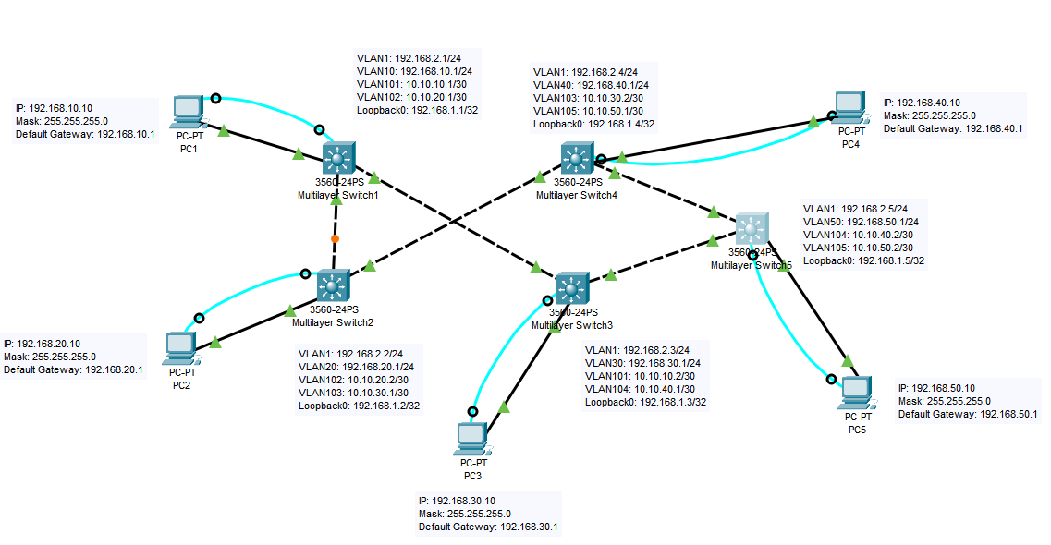

1. Submit full screen normalized “show vlan” output from each MLS1-5 for this homework

MSL1

MSL2

MSL3

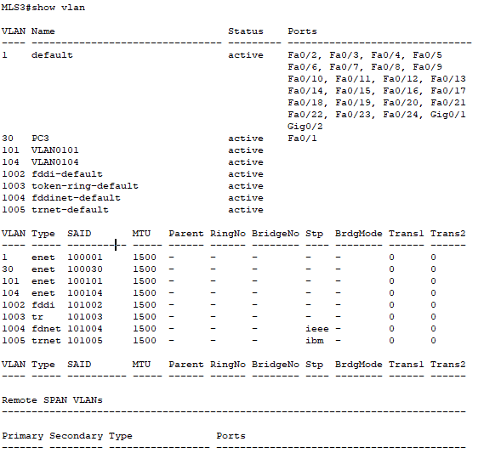

MSL4

MSL5

1. Verify Management console connectivity from PC1-5 to MLS1-5 respectively by logging into the MLS1-5 using telnet

|  |  |  |  |  |  |
| --- | --- | --- | --- | --- | --- |
|  | MLS1 | MLS2 | MLS3 | MLS4 | MLS5 |
| PC1 | C:\>telnet 192.168.2.1  Trying 192.168.2.1 ...OpenNo unauthorized access allowed!  User Access Verification  Password:  MLS1> | C:\>telnet 192.168.2.2  Trying 192.168.2.2 ...  % Connection timed out; remote host not responding | C:\>telnet 192.168.2.3  Trying 192.168.2.3 ...  % Connection timed out; remote host not responding | C:\>telnet 192.168.2.4  Trying 192.168.2.4 ...  % Connection timed out; remote host not responding | C:\>telnet 192.168.2.5  Trying 192.168.2.5 ...  % Connection timed out; remote host not responding |
| PC2 | C:\>telnet 192.168.2.1  Trying 192.168.2.1 ...  % Connection timed out; remote host not responding | C:\>telnet 192.168.2.2  Trying 192.168.2.2 ...OpenNo unauthorized access allowed!  User Access Verification  Password:  MLS2> | C:\>telnet 192.168.2.3  Trying 192.168.2.3 ...  % Connection timed out; remote host not responding | C:\>telnet 192.168.2.4  Trying 192.168.2.4 ...  % Connection timed out; remote host not responding | C:\>telnet 192.168.2.5  Trying 192.168.2.5 ...  % Connection timed out; remote host not responding |
| PC3 | C:\>telnet 192.168.2.1  Trying 192.168.2.1 ...  % Connection timed out; remote host not responding | C:\>telnet 192.168.2.2  Trying 192.168.2.2 ...  % Connection timed out; remote host not responding | C:\>telnet 192.168.2.3  Trying 192.168.2.3 ...OpenNo unauthorized access allowed!  User Access Verification  Password:  MLS3> | C:\>telnet 192.168.2.4  Trying 192.168.2.4 ...  % Connection timed out; remote host not responding | C:\>telnet 192.168.2.5  Trying 192.168.2.5 ...  % Connection timed out; remote host not responding |
| PC4 | C:\>telnet 192.168.2.1  Trying 192.168.2.1 ...  % Connection timed out; remote host not responding | C:\>telnet 192.168.2.2  Trying 192.168.2.2 ...  % Connection timed out; remote host not responding | C:\>telnet 192.168.2.3  Trying 192.168.2.3 ...  % Connection timed out; remote host not responding | C:\>telnet 192.168.2.4  Trying 192.168.2.4 ...OpenNo unauthorized access allowed!  User Access Verification  Password:  MLS4> | C:\>telnet 192.168.2.5  Trying 192.168.2.5 ...  % Connection timed out; remote host not responding |
| PC5 | C:\>telnet 192.168.2.1  Trying 192.168.2.1 ...  % Connection timed out; remote host not responding | C:\>telnet 192.168.2.2  Trying 192.168.2.2 ...  % Connection timed out; remote host not responding | C:\>telnet 192.168.2.3  Trying 192.168.2.3 ...  % Connection timed out; remote host not responding | C:\>telnet 192.168.2.4  Trying 192.168.2.4 ...  % Connection timed out; remote host not responding | C:\>telnet 192.168.2.5  Trying 192.168.2.5 ...OpenNo unauthorized access allowed!  User Access Verification  Password:  MLS5> |

1. Verify MLS1-5 management network vlan 1 connectivity from each MLS with ping command

|  |  |  |  |  |  |
| --- | --- | --- | --- | --- | --- |
|  | MLS1 | MLS2 | MLS3 | MLS4 | MLS5 |
| MLS1 | ======== | MLS1>ping 192.168.2.2  Type escape sequence to abort.  Sending 5, 100-byte ICMP Echos to 192.168.2.2, timeout is 2 seconds:  !!!!!  Success rate is 100 percent (5/5), round-trip min/avg/max = 0/2/12 ms | MLS1>ping 192.168.2.3  Type escape sequence to abort.  Sending 5, 100-byte ICMP Echos to 192.168.2.3, timeout is 2 seconds:  !!!!!  Success rate is 100 percent (5/5), round-trip min/avg/max = 0/0/0 ms | MLS1>ping 192.168.2.4  Type escape sequence to abort.  Sending 5, 100-byte ICMP Echos to 192.168.2.4, timeout is 2 seconds:  !!!!!  Success rate is 100 percent (5/5), round-trip min/avg/max = 1/3/12 ms | MLS1>ping 192.168.2.5  Type escape sequence to abort.  Sending 5, 100-byte ICMP Echos to 192.168.2.5, timeout is 2 seconds:  !!!!!  Success rate is 100 percent (5/5), round-trip min/avg/max = 0/0/0 ms |
| MLS2 | MLS2>ping 192.168.2.1  Type escape sequence to abort.  Sending 5, 100-byte ICMP Echos to 192.168.2.1, timeout is 2 seconds:  !!!!!  Success rate is 100 percent (5/5), round-trip min/avg/max = 0/11/35 ms | ======== | MLS2>ping 192.168.2.3  Type escape sequence to abort.  Sending 5, 100-byte ICMP Echos to 192.168.2.3, timeout is 2 seconds:  !!!!!  Success rate is 100 percent (5/5), round-trip min/avg/max = 0/3/12 ms | MLS2>ping 192.168.2.4  Type escape sequence to abort.  Sending 5, 100-byte ICMP Echos to 192.168.2.4, timeout is 2 seconds:  !!!!!  Success rate is 100 percent (5/5), round-trip min/avg/max = 0/0/0 ms | MLS2>ping 192.168.2.5  Type escape sequence to abort.  Sending 5, 100-byte ICMP Echos to 192.168.2.5, timeout is 2 seconds:  !!!!!  Success rate is 100 percent (5/5), round-trip min/avg/max = 0/0/2 ms |
| MLS3 | MLS3>ping 192.168.2.1  Type escape sequence to abort.  Sending 5, 100-byte ICMP Echos to 192.168.2.1, timeout is 2 seconds:  !!!!!  Success rate is 100 percent (5/5), round-trip min/avg/max = 0/0/0 ms | MLS3>ping 192.168.2.2  Type escape sequence to abort.  Sending 5, 100-byte ICMP Echos to 192.168.2.2, timeout is 2 seconds:  !!!!!  Success rate is 100 percent (5/5), round-trip min/avg/max = 0/0/1 ms | ======== | MLS3>ping 192.168.2.4  Type escape sequence to abort.  Sending 5, 100-byte ICMP Echos to 192.168.2.4, timeout is 2 seconds:  !!!!!  Success rate is 100 percent (5/5), round-trip min/avg/max = 0/0/2 ms | MLS3>ping 192.168.2.5  Type escape sequence to abort.  Sending 5, 100-byte ICMP Echos to 192.168.2.5, timeout is 2 seconds:  !!!!!  Success rate is 100 percent (5/5), round-trip min/avg/max = 0/0/0 ms |
| MLS4 | MLS4>ping 192.168.2.1  Type escape sequence to abort.  Sending 5, 100-byte ICMP Echos to 192.168.2.1, timeout is 2 seconds:  !!!!!  Success rate is 100 percent (5/5), round-trip min/avg/max = 0/1/3 ms | MLS4>ping 192.168.2.2  Type escape sequence to abort.  Sending 5, 100-byte ICMP Echos to 192.168.2.2, timeout is 2 seconds:  !!!!!  Success rate is 100 percent (5/5), round-trip min/avg/max = 0/0/0 ms | MLS4>ping 192.168.2.3  Type escape sequence to abort.  Sending 5, 100-byte ICMP Echos to 192.168.2.3, timeout is 2 seconds:  !!!!!  Success rate is 100 percent (5/5), round-trip min/avg/max = 0/0/2 ms | ======== | MLS4>ping 192.168.2.5  Type escape sequence to abort.  Sending 5, 100-byte ICMP Echos to 192.168.2.5, timeout is 2 seconds:  !!!!!  Success rate is 100 percent (5/5), round-trip min/avg/max = 0/0/0 ms |
| MLS5 | MLS5>ping 192.168.2.1  Type escape sequence to abort.  Sending 5, 100-byte ICMP Echos to 192.168.2.1, timeout is 2 seconds:  !!!!!  Success rate is 100 percent (5/5), round-trip min/avg/max = 0/0/2 ms | MLS5>ping 192.168.2.2  Type escape sequence to abort.  Sending 5, 100-byte ICMP Echos to 192.168.2.2, timeout is 2 seconds:  !!!!!  Success rate is 100 percent (5/5), round-trip min/avg/max = 0/0/1 ms | MLS5>ping 192.168.2.3  Type escape sequence to abort.  Sending 5, 100-byte ICMP Echos to 192.168.2.3, timeout is 2 seconds:  !!!!!  Success rate is 100 percent (5/5), round-trip min/avg/max = 0/0/0 ms | MLS5>ping 192.168.2.4  Type escape sequence to abort.  Sending 5, 100-byte ICMP Echos to 192.168.2.4, timeout is 2 seconds:  !!!!!  Success rate is 100 percent (5/5), round-trip min/avg/max = 0/0/0 ms | ======== |

1. Verify MLS1-5 loopback interface connectivity from PC1-5 with telnet command

|  |  |  |  |  |  |
| --- | --- | --- | --- | --- | --- |
|  | MLS1 | MLS2 | MLS3 | MLS4 | MLS5 |
| PC1 | C:\>telnet 192.168.1.1  Trying 192.168.1.1 ...OpenNo unauthorized access allowed!  User Access Verification  Password:  MLS1> | C:\>telnet 192.168.1.2  Trying 192.168.1.2 ...  % Connection timed out; remote host not responding | C:\>telnet 192.168.1.3  Trying 192.168.1.3 ...  % Connection timed out; remote host not responding | C:\>telnet 192.168.1.4  Trying 192.168.1.4 ...  % Connection timed out; remote host not responding | C:\>telnet 192.168.1.5  Trying 192.168.1.5 ...  % Connection timed out; remote host not responding |
| PC2 | C:\>telnet 192.168.1.1  Trying 192.168.1.1 ...  % Connection timed out; remote host not responding | C:\>telnet 192.168.1.2  Trying 192.168.1.2 ...OpenNo unauthorized access allowed!  User Access Verification  Password:  MLS2> | C:\>telnet 192.168.1.3  Trying 192.168.1.3 ...  % Connection timed out; remote host not responding | C:\>telnet 192.168.1.4  Trying 192.168.1.4 ...  % Connection timed out; remote host not responding | C:\>telnet 192.168.1.5  Trying 192.168.1.5 ...  % Connection timed out; remote host not responding |
| PC3 | C:\>telnet 192.168.1.1  Trying 192.168.1.1 ...  % Connection timed out; remote host not responding | C:\>telnet 192.168.1.2  Trying 192.168.1.2 ...  % Connection timed out; remote host not responding | C:\>telnet 192.168.1.3  Trying 192.168.1.3 ...OpenNo unauthorized access allowed!  User Access Verification  Password:  MLS3> | C:\>telnet 192.168.1.4  Trying 192.168.1.4 ...  % Connection timed out; remote host not responding | C:\>telnet 192.168.1.5  Trying 192.168.1.5 ...  % Connection timed out; remote host not responding |
| PC4 | C:\>telnet 192.168.1.1  Trying 192.168.1.1 ...  % Connection timed out; remote host not responding | C:\>telnet 192.168.1.2  Trying 192.168.1.2 ...  % Connection timed out; remote host not responding | C:\>telnet 192.168.1.3  Trying 192.168.1.3 ...  % Connection timed out; remote host not responding | C:\>telnet 192.168.1.4  Trying 192.168.1.4 ...OpenNo unauthorized access allowed!  User Access Verification  Password:  MLS4> | C:\>telnet 192.168.1.5  Trying 192.168.1.5 ...  % Connection timed out; remote host not responding |
| PC5 | C:\>telnet 192.168.1.1  Trying 192.168.1.1 ...  % Connection timed out; remote host not responding | C:\>telnet 192.168.1.2  Trying 192.168.1.2 ...  % Connection timed out; remote host not responding | C:\>telnet 192.168.1.3  Trying 192.168.1.3 ...  % Connection timed out; remote host not responding | C:\>telnet 192.168.1.4  Trying 192.168.1.4 ...  % Connection timed out; remote host not responding | C:\>telnet 192.168.1.5  Trying 192.168.1.5 ...OpenNo unauthorized access allowed!  User Access Verification  Password:  MLS5> |

1. Compile all your output Items 1 – 2 with proper identification in a word document and log your console output for the test “3, 4, 5, 6 above” and upload the file to Canvas for Homework 5.
2. Also include items 4 - 6 in print format in your word file for grading.
3. We will use this Packet Tracer activity for Routing Protocol Labs7-8. Please make sure you have everything completed before Lab7-8 date.

**Please note that the grading for Homeworks and Labs require that you configure correct vlans on the switch and trunk based on the design. Configuring access vlans or configuring all vlans on trunk is a very bad idea. I have seen many networks destroyed by this bad practice. I want to make sure that you do not learn to do that. You will not get full credit for work if you use this bad practice for homeworks and Labs.**